**Cloud Computing**

In Simplest terms, cloud computing means storing and accessing the data and programs on remote servers that are hosted on the internet instead of the computer’s hard drive or local server. Cloud computing is also referred to as Internet-based computing.

Cloud computing delivers computing resources such as storage, databases, applications, networking capabilities, and more by service providers (also known as Cloud Service Providers or CSPs) to their clients through the internet, which is known as cloud computing.

No longer are users confined to the resources of their hardware or software but are instead able to access data, applications, and services housed on distant servers from anywhere in the world. Since you will only pay for the cloud services that you use, you may reduce your operating expenses while simultaneously increasing the efficiency of your network.

## **Need for Cloud Computing**

Before the advent of cloud computing, businesses were required to keep all essential information and software on their hard disks and servers. The bigger the organization's size, the more storage space was needed. This primitive method of handling data prevented scalability in terms of speed. In addition, the IT staff had much work to do because of the brisk business.

Cloud computing has several advantages for individuals as well as corporations. As people, cloud computing has had a significant impact on our lives. Cloud computing services are used by us daily. When we use cloud-based apps to update our statuses on our favourite social media sites while binge-watching or checking out bank accounts, we most likely utilize applications using cloud services. This kind of software is accessible via an internet connection. It does not need to be downloaded on our computers or mobile devices, which is the essential characteristic of Cloud Computing.

The advent of cloud computing has enabled businesses to expand and acclimate at an unprecedented pace and scale, accelerating innovation, driving business agility, streamlining processes, and lowering costs. This may assist companies in navigating the present economic crisis, but it can also result in enhanced, long-term development. They are experiencing revenue growth that is further than double as fast as that of organizations that are hesitant to deploy and utilize their technology. In reality, 95 percent of business executives have used advanced cloud services.

**Benefits of Cloud Hosting:**

1. **Scalability:** With Cloud hosting, it is easy to grow and shrink the number and size of servers based on the need. This is done by either increasing or decreasing the resources in the cloud. This ability to alter plans due to fluctuation in business size and needs is a superb benefit of cloud computing, especially when experiencing a sudden growth in demand.
2. **Instant:** Whatever you want is instantly available in the cloud.
3. **Save Money:** An advantage of cloud computing is the reduction in hardware costs. Instead of purchasing in-house equipment, hardware needs are left to the vendor. For companies that are growing rapidly, new hardware can be large, expensive, and inconvenient. Cloud computing alleviates these issues because resources can be acquired quickly and easily. Even better, the cost of repairing or replacing equipment is passed to the vendors. Along with purchase costs, off-site hardware cuts internal power costs and saves space. Large data centers can take up precious office space and produce a large amount of heat. Moving to cloud applications or storage can help maximize space and significantly cut energy expenditures.
4. **Reliability:**Rather than being hosted on one single instance of a physical server, hosting is delivered on a virtual partition that draws its resource, such as disk space, from an extensive network of underlying physical servers. If one server goes offline it will have no effect on availability, as the virtual servers will continue to pull resources from the remaining network of servers.
5. **Physical Security:** The underlying physical servers are still housed within data centers and so benefit from the security measures that those facilities implement to prevent people from accessing or disrupting them on-site.
6. **Outsource Management:** When you are managing the business, Someone else manages your computing infrastructure. You do not need to worry about management as well as upgradation.

To more clarification about how cloud computing has changed the commercial deployment of the system. Consider above the three examples:

1. **Amazon Web Services(AWS):**One of the most successful cloud-based businesses is Amazon Web Services(AWS), which is an Infrastructure as a Service(Iaas) offering that pays rent for virtual computers on Amazon’s infrastructure.
2. **Microsoft Azure Platform**: Microsoft is creating the Azure platform which enables the .NET Framework Application to run over the internet as an alternative platform for Microsoft developers. This is the classic Platform as a Service(PaaS).
3. **Google:**Google has built a worldwide network of datacenters to service its search engine. From this service, Google has captured the world’s advertising revenue. By using that revenue, Google offers free software to users based on infrastructure. This is called Software as a Service(SaaS).

## Advantages of using Cloud

The advantages for using cloud services can be of technical, architectural, business .

* + 1. Cloud Providers’ point of view
       1. Most of the data centers today are under utilized. They are mostly 15% utilized. These data centers need spare capacity just to cope with the huge spikes that sometimes get in the server usage. Large companies having those data centers can easily rent those computing power to other organizations and get profit out of it and also make the resources needed for running data center (like power) utilized properly.
       2. Companies having large data centers have already deployed the resources and to provide cloud services they would need very little investment and the cost would be incremental.
    2. Cloud Users’ point of view
       1. Cloud users need not to take care about the hardware and software they use and also they don’t have to be worried about maintenance. The users are no longer tied to some one traditional system.
       2. Virtualization technology gives the illusion to the users that they are having all the resources available.
       3. Cloud users can use the resources on demand basis and pay as much as they use. So the users can plan well for reducing their usage to minimize their expenditure.
       4. Scalability is one of the major advantages to cloud users. Scalability is provided dynamically to the users. Users get as much resources as they need. Thus this model perfectly fits in the management of rare spikes in the demand.

**Characteristics of Cloud Computing**

These are basically essential characteristics of [Cloud Computing](https://www.geeksforgeeks.org/cloud-computing/).

1. **On-demand self-services:**

The Cloud computing services does not require any human administrators, user themselves are able to provision, monitor and manage computing resources as needed.

It is one of the most central and vital elements of Cloud Computing that is crucial and necessary. In addition, it allows the client to keep track of the server's uptime, capabilities, and available network storage space. A significant property of Cloud Computer is that it will enable a customer to manage computing resources according to their requirements.

1. **Broad network access:**  
   The Computing services are generally provided over standard networks and heterogeneous devices.
2. **Scalability and Rapid elasticity:**  
   The Computing services should have IT resources that are able to scale out and in quickly and on as needed basis. Whenever the user require services it is provided to him and it is scale out as soon as its requirement gets over.

Cloud computing's capacity to rapidly grow and shrink is a significant benefit and characteristic. This cloud feature facilitates the cost-effective operation of workloads that need many servers but are only required for a short period, such as database servers. As a result of the rapid elasticity in Cloud Computing, many customers have workloads that can be performed highly cost-effectively at a low cost.

1. **Resource pooling:**  
   The IT resource (e.g., networks, servers, storage, applications, and services) present are shared across multiple applications and occupant in an uncommitted manner. Multiple clients are provided service from a same physical resource.

The ability to pool resources is one of the essential characteristics of cloud computing. Resource pooling in cloud computing refers to the power of a cloud service provider to share resources across several customers. Each receives a unique set of services tailored to their specific needs. Data storage services, processing services, and bandwidth provisioning services are examples of multi-client strategies that may be used in various situations. There is no conflict between the administration process and the client's experience since resources are allocated in real-time.

1. **Measured service:**  
   The resource utilization is tracked for each application and occupant, it will provide both the user and the resource provider with an account of what has been used. This is done for various reasons like monitoring billing and effective use of resource. One of the many essential characteristics of Cloud Computing that make it the ideal option for enterprises is the availability of reporting services. Measured services in Cloud Computing are beneficial to both cloud providers and their customers. It helps both the supplier and the customer keep track of and report on the services that have been utilized and for what purpose they have been used—this aids in monitoring bills and the assurance of the most efficient use of available resources.
2. Easy Care And Maintenance

This is one of the most desirable characteristics of Cloud Computing. In addition, the servers are easily maintained, and downtime is kept to a bare minimum or even nil in some instances. Frequently, upgrades are made to cloud computing-powered services to improve their capabilities and potential. According to the company, the enhancements are more compatible with the devices and operate more quickly than the prior versions.

7. Economic Considerations

This aspect of the cloud assists enterprises in lowering their overall IT expenditures. In Cloud Computing, the customer is responsible for compensating the administration for the space they have used while using the service. No further payment or cover-up has to be paid in this instance. As a result, the administration is frugal, and more often than not, some space is made available for free to the administration.

8. Security Is An Important Feature

One of the most advantageous characteristics of Cloud Computing is the protection of personal data. Cloud computing services make a backup copy of the saved data to avoid data loss. If one of the servers loses the data by accident, the copied version from the other server is used to recover the data. This capability comes in handy when several people work on a single file in real-time, and the file becomes corrupted simultaneously.

9. Automated Systems

Cloud computing is distinguished by the fact that it is entirely automated. In layman's words, it is getting the most out of technology while simultaneously eliminating physical labor. However, attaining computerization in the cloud network is not without its difficulties. There is a need to install and configure virtual technologies, servers, and enormous amounts of storage. Following a positive placement, these properties will need to be maintained regularly.

10. Resistance To Change

Resilience refers to the service's capacity to swiftly pull through from any interruption in cloud computing. The strength of a cloud is assessed by how quickly its databases, servers, and network infrastructure can restart and recover after being subjected to any form of injury or damage. Another essential property of cloud computing is its high level of availability. Given that cloud services may be accessed from anywhere globally, there are no geographical restrictions or limitations to using cloud properties.

11. Access To A Large Network

The cloud's widespread availability accounts for an essential characteristic of cloud computing. A device and an internet connection are required for the client to view cloud information or send information to the cloud from anywhere. These capabilities are available across the company and may be accessed via the internet. Cloud providers reduce the need for significant network access by monitoring and assuring a variety of metrics that represent how customers access cloud services and data, such as data throughput, access time, latency, and so on, which cloud providers save.

Cloud Architecture

**Cloud Computing Architecture:** Cloud computing architecture refers to the components and sub-components required for cloud computing. These components typically refer to:

1. Front end(fat client, thin client)
2. Back-end platforms(servers, storage)
3. Cloud-based delivery and a network(Internet, Intranet, Intercloud).

**Hosting a cloud:** There are three layers in cloud computing. Companies use these layers based on the service they provide.

* Infrastructure
* Platform
* Application

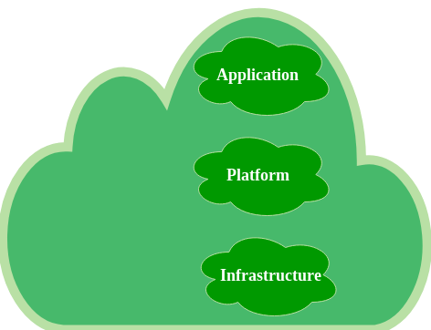

*Three layers of Cloud Computing*

At the bottom is the foundation, the Infrastructure where the people start and begin to build. This is the layer where the cloud hosting lives. **Now, let’s have a look at hosting:** Let’s say you have a company and a website and the website has a lot of communications that are exchanged between members. You start with a few members talking with each other and then gradually the number of members increases. As the time passes, as the number of members increases, there would be more traffic on the network and your server will get slow down. This would cause a problem. A few years ago, the websites are put on the server somewhere, in this way you have to run around or buy and set the number of servers. It costs a lot of money and takes a lot of time. You pay for these servers when you are using them and as well as when you are not using them. This is called hosting. This problem is overcome by cloud hosting. With Cloud Computing, you have access to computing power when you needed. Now, your website is put in the cloud server as you put it on a dedicated server. People start visiting your website and if you suddenly need more computing power, you would scale up according to the need.

The cloud providers actually have the physical data centers to provide virtualized services to their users through Internet. The cloud providers often provide separa- tion between application and data. This scenario is shown in the Figure 2. The underlying physical machines are generally organized in grids and they are usu- ally geographically distributed. Virtualization plays an important role in the cloud scenario. The data center hosts provide the physical hardware on which virtual ma- chines resides. User potentially can use any OS supported by the virtual machines used.

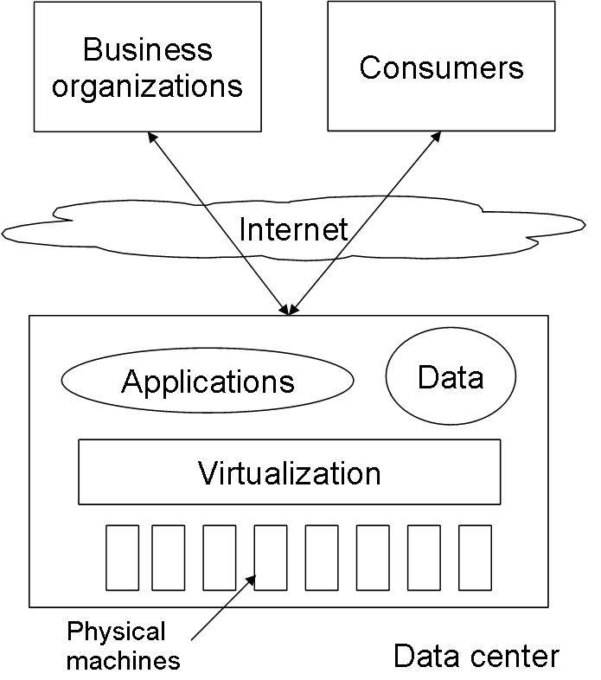

Figure 2: Basic Cloud Computing Architecture

Operating systems are designed for specific hardware and software. It results in the lack of portability of operating system and software from one machine to another machine which uses different instruction set architecture. The concept of virtual machine solves this problem by acting as an interface between the hardware and the operating system called as system VMs [21]. Another category of virtual machine is called process virtual machine which acts as an abstract layer between the operating system and applications. Virtualization can be very roughly said to be as software translating the hardware instructions generated by conventional soft- ware to the understandable format for the physical hardware. Virtualization also includes the mapping of virtual resources like registers and memory to real hard- ware resources. The underlying platform in virtualization is generally referred to as host and the software that runs in the VM environment is called as the guest. The Figure 3 shows very basics of virtualization. Here the virtualization layer cov- ers the physical hardware. Operating System accesses physical hardware through virtualization layer. Applications can issue instruction by using OS interface as well as directly using virtualizing layer interface. This design enables the users to use applications not compatible with the operating system.

Virtualization enables the migration of the virtual image from one physical machine to another and this feature is useful for cloud as by data locality lots of optimization is possible and also this feature is helpful for taking back up in different locations. This feature also enables the provider to shut down some of the data center physical machines to reduce power consumption.

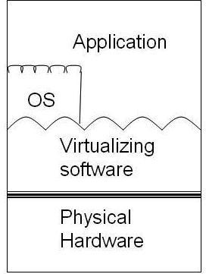

Figure 3: Virtualization basic

# Types of Cloud

There are the following 4 types of cloud that you can deploy according to the organization's needs-

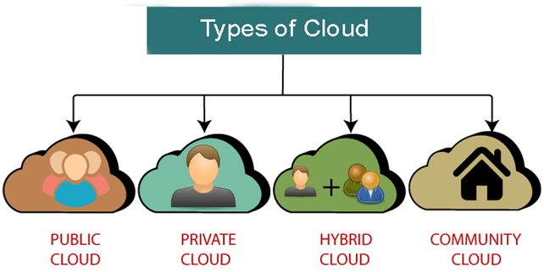

* [Public Cloud](https://www.javatpoint.com/types-of-cloud#Public)
* [Private Cloud](https://www.javatpoint.com/types-of-cloud#Private)
* [Hybrid Cloud](https://www.javatpoint.com/types-of-cloud#Hybrid)
* [Community Cloud](https://www.javatpoint.com/types-of-cloud#Community)

## **Public Cloud**

Public cloud is **open to all** to store and access information via the Internet using the pay-per-usage method.

In public cloud, computing resources are managed and operated by the Cloud Service Provider (CSP).

**Example:** Amazon elastic compute cloud (EC2), IBM SmartCloud Enterprise, Microsoft, Google App Engine, Windows Azure Services Platform.

Public clouds are managed by third parties which provide cloud services over the internet to the public, these services are available as pay-as-you-go billing models.   
They offer solutions for minimizing IT infrastructure costs and become a good option for handling peak loads on the local infrastructure. Public clouds are the go-to option for small enterprises, which can start their businesses without large upfront investments by completely relying on public infrastructure for their IT needs.   
The fundamental characteristics of public clouds are **multitenancy**. A public cloud is meant to serve multiple users, not a single customer. A user requires a virtual computing environment that is separated, and most likely isolated, from other users.

Exception Handling in Java - Javatpoint

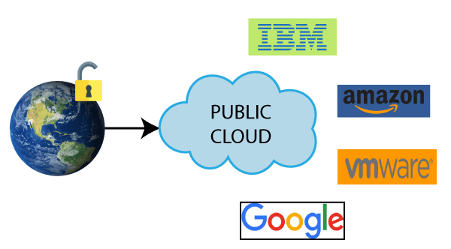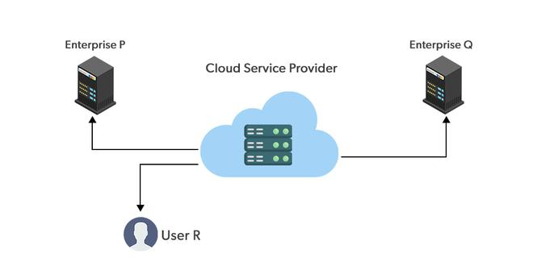

### **Advantages of Public Cloud**

There are the following advantages of Public Cloud -

* Public cloud is owned at a lower cost than the private and hybrid cloud.
* Public cloud is maintained by the cloud service provider, so do not need to worry about the maintenance.
* Public cloud is easier to integrate. Hence it offers a better flexibility approach to consumers.
* Public cloud is location independent because its services are delivered through the internet.
* Public cloud is highly scalable as per the requirement of computing resources.
* It is accessible by the general public, so there is no limit to the number of users.

### **Disadvantages of Public Cloud**

* Public Cloud is less secure because resources are shared publicly.
* Performance depends upon the high-speed internet network link to the cloud provider.
* The Client has no control of data.

**To Read More** [**Click Here**](https://www.javatpoint.com/public-cloud)

## **Private Cloud**

Private cloud is also known as an **internal cloud** or **corporate cloud**. It is used by organizations to build and manage their own data centers internally or by the third party. It can be deployed using Opensource tools such as Openstack and Eucalyptus.

Based on the location and management, National Institute of Standards and Technology (NIST) divide private cloud into the following two parts-

* On-premise private cloud
* Outsourced private cloud

Private clouds are distributed systems that work on private infrastructure and provide the users with dynamic provisioning of computing resources. Instead of a pay-as-you-go model in private clouds, there could be other schemes that manage the usage of the cloud and proportionally billing of the different departments or sections of an enterprise. Private cloud providers are HP Data Centers, Ubuntu, Elastic-Private cloud, Microsoft, etc.

* 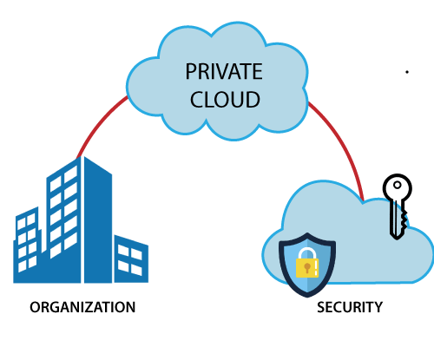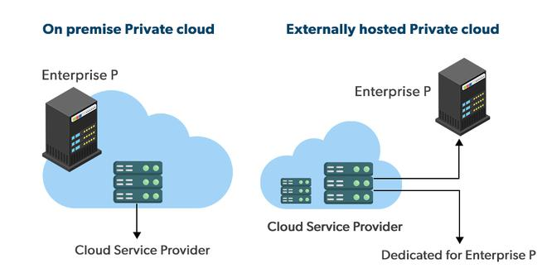

### **Advantages of Private Cloud**

There are the following advantages of the Private Cloud -

* Private cloud provides a high level of security and privacy to the users.
* Private cloud offers better performance with improved speed and space capacity.
* It allows the IT team to quickly allocate and deliver on-demand IT resources.
* The organization has full control over the cloud because it is managed by the organization itself. So, there is no need for the organization to depends on anybody.
* It is suitable for organizations that require a separate cloud for their personal use and data security is the first priority.

### **Disadvantages of Private Cloud**

* Skilled people are required to manage and operate cloud services.
* Private cloud is accessible within the organization, so the area of operations is limited.
* Private cloud is not suitable for organizations that have a high user base, and organizations that do not have the prebuilt infrastructure, sufficient manpower to maintain and manage the cloud.

## **Hybrid Cloud**

Hybrid Cloud is a combination of the public cloud and the private cloud. we can say:

***Hybrid Cloud = Public Cloud + Private Cloud***

Hybrid cloud is partially secure because the services which are running on the public cloud can be accessed by anyone, while the services which are running on a private cloud can be accessed only by the organization's users.

A hybrid cloud is a heterogeneous distributed system formed by combining facilities of the public cloud and private cloud. For this reason, they are also called **heterogeneous clouds.**   
A major drawback of private deployments is the inability to scale on-demand and efficiently address peak loads. Here public clouds are needed. Hence, a hybrid cloud takes advantage of both public and private clouds.

**Example:** Google Application Suite (Gmail, Google Apps, and Google Drive), Office 365 (MS Office on the Web and One Drive), Amazon Web Services.

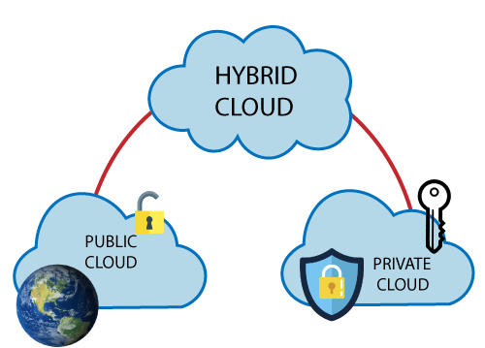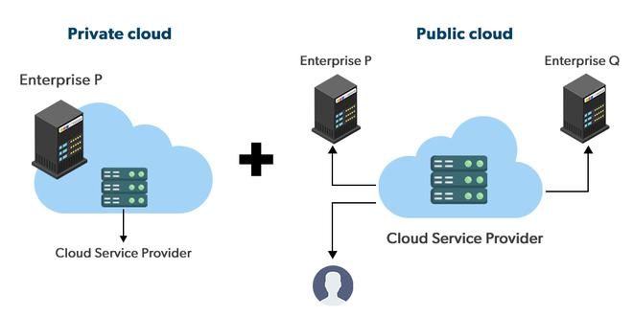

### **Advantages of Hybrid Cloud**

There are the following advantages of Hybrid Cloud -

* Hybrid cloud is suitable for organizations that require more security than the public cloud.
* Hybrid cloud helps you to deliver new products and services more quickly.
* Hybrid cloud provides an excellent way to reduce the risk.
* Hybrid cloud offers flexible resources because of the public cloud and secure resources because of the private cloud.

### **Disadvantages of Hybrid Cloud**

* In Hybrid Cloud, security feature is not as good as the private cloud.
* Managing a hybrid cloud is complex because it is difficult to manage more than one type of deployment model.
* In the hybrid cloud, the reliability of the services depends on cloud service providers.

## **Community Cloud**

Community cloud allows systems and services to be accessible by a group of several organizations to share the information between the organization and a specific community. It is owned, managed, and operated by one or more organizations in the community, a third party, or a combination of them.

Community clouds are distributed systems created by integrating the services of different clouds to address the specific needs of an industry, a community, or a business sector. But sharing responsibilities among the organizations is difficult.

In the community cloud, the infrastructure is shared between organizations that have shared concerns or tasks. The cloud may be managed by an organization or a third party.

**Example:** Health Care community cloud

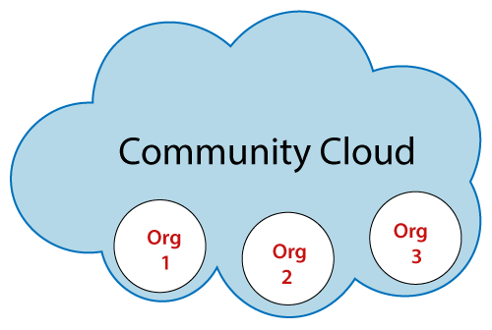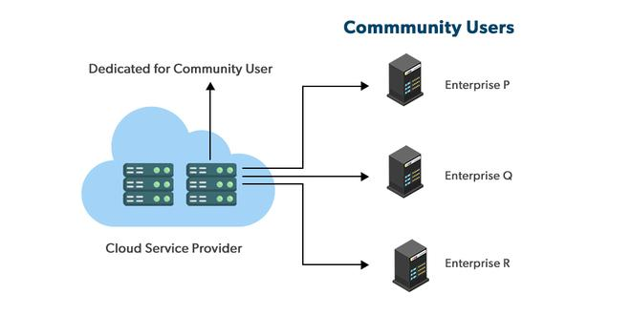

### **Advantages of Community Cloud**

There are the following advantages of Community Cloud -

* Community cloud is cost-effective because the whole cloud is being shared by several organizations or communities.
* Community cloud is suitable for organizations that want to have a collaborative cloud with more security features than the public cloud.
* It provides better security than the public cloud.
* It provdes collaborative and distributive environment.
* Community cloud allows us to share cloud resources, infrastructure, and other capabilities among various organizations.

### **Disadvantages of Community Cloud**

* Community cloud is not a good choice for every organization.
* Security features are not as good as the private cloud.
* It is not suitable if there is no collaboration.
* The fixed amount of data storage and bandwidth is shared among all community members.

**Sectors that use community clouds are:**

**1. Media industry:** Media companies are looking for quick, simple, low-cost ways for increasing the efficiency of content generation. Most media productions involve an extended ecosystem of partners. In particular, the creation of digital content is the outcome of a collaborative process that includes the movement of large data, massive compute-intensive rendering tasks, and complex workflow executions.

**2. Healthcare industry:** In the healthcare industry community clouds are used to share information and knowledge on the global level with sensitive data in the private infrastructure.

**3. Energy and core industry:** In these sectors, the community cloud is used to cluster a set of solution which collectively addresses the management, deployment, and orchestration of services and operations.

**4. Scientific research:** In this organization with common interests in science share a large distributed infrastructure for scientific computing.

## **Difference between public cloud, private cloud, hybrid cloud, and community cloud -**

The below table shows the difference between public cloud, private cloud, hybrid cloud, and community cloud.

| **Parameter** | **Public Cloud** | **Private Cloud** | **Hybrid Cloud** | **Community Cloud** |
| --- | --- | --- | --- | --- |
| **Host** | Service provider | Enterprise (Third party) | Enterprise (Third party) | Community (Third party) |
| **Users** | General public | Selected users | Selected users | Community members |
| **Access** | Internet | Internet, VPN | Internet, VPN | Internet, VPN |
| **Owner** | Service provider | Enterprise | Enterprise | Community |